The Voice of Queenslanders with Disability

Health and wellbeing
Australia’s Disability Strategy aims to make Australia a place where people with disability can fulfil their potential as equals (be who they are, live the lives they want to live, and be treated the same as others). Queensland’s Disability Plan 2022-2027: Together, a better Queensland will help to achieve this across the state, in a way that recognises Queensland’s unique peoples, regions and diversity. This paragraph draws from references one and two.

Queensland’s Disability Plan has seven outcome areas:
- Working and earning money
- Inclusive homes and communities
- Rights, fairness and safety
- Getting support
- Learning and skills
- Health and wellbeing
- Community attitudes
This information focuses on Health and wellbeing.

The Voice of Queenslanders with Disability will find out how these areas are changing over time. You can start having your say in early 2023 and we will produce an annual report that summarises what is happening for Queenslanders with disability.

Where do we want to be in ten years?
Good health and wellbeing can help people with disability enjoy their lives.
Queenslanders with disability should:
- Be able to access health services that meets their needs.
- Get appropriate and timely mental health care and support.
- Feel safe in the community through appropriate emergency plans.
These points draw from reference one.

What do we know about health and wellbeing for Queenslanders with disability now?
- People with disability are more likely to rate their health as fair or poor (42%) than people without disability (7%), and less likely to rate their health as excellent or very good (24% compared to 65%).
- They are also more likely to experience a high or very high level of psychological distress (42% of people with disability compared to 7% for people without disability).
- Some people with disability (8%) delay or avoid seeing a GP due to cost.
These points draw from reference three.

Intersectionality matters
- First Nations Queenslanders are more likely to have disability (35.6%) than other Queenslanders (18%).
- 63% of First Nations Queenslanders have one or more current long-term health condition(s), compared to 41.8% of other Queenslanders.
- Around 140,000 First Nations Queenslanders with disability have trouble accessing health services. The biggest barriers are cost, being too busy, dislikes, and deciding not to seek care.
These points draw from references three and five.

What do Queenslanders with disability say about health and wellbeing?

Health and wellbeing can be difficult when health care environments, staff, and systems are not safe, dignified and welcoming for people with diverse needs.
- “Health is a full-time job. It’s really hard to be in the things that you really wanted to …it takes a lot of work not to be some of the symptoms of your condition.”
- “The kind of world that we live in, [is one] where documentation surrounding injury has more weight than the person themselves.”
- “An allied health person when discussing my condition with another allied health worker did not include me in the conversation.”
These points draw from reference six.

How did COVID-19 impact health and wellbeing?
- “I have used telehealth appointments during COVID-19 for medical appointments. This has worked well and is important to me as I have secondary health conditions related to my disability which puts me more at risk.”
- “The increased use of technology to connect, such as telehealth, has enabled me to stay connected and live better.”
- “Live saving care and regular care was not always easily available or accessible for disabled people (during the pandemic).”
These points draw from reference six.

What helps people with disability feel healthier and more well?
- “I use medicine wise the app which has all my medication. It’s a not-for-profit app and I found that before I did that, I couldn’t cope.”
- I have a 2- sided full page that I carry in my phone case with all my health conditions, allergies, medications and specialists. My doctor gets a copy of that.”
- “All of my doctors now will turn off the artificial light above my head and change the lighting. They do that before I even come in the room now. If it’s a new doctor, they’ve usually been briefed by who has referred me.”
- “When I am given the opportunity to express myself like other people.”
These points draw from reference six.

Where to next?
Queenslanders with disability and their family/carers (as well as disability organisations and service providers) will be able to share their experiences on the vision and seven areas of Australia’s Disability Strategy and Queensland’s State Disability Plan in early 2023.

More information and an opportunity to register your interest is available at The Dignity Project website: The Voices of Queenslanders with Disability Link.

QR Code
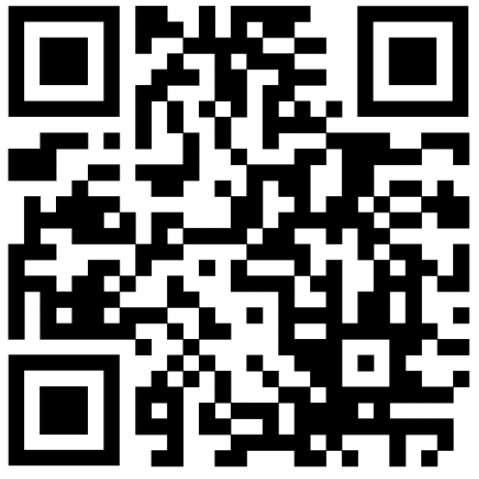

References
- Commonwealth of Australia, Department of Social Services. (2021). Australia’s Disability Strategy 2021-2031. Disability Gateway link
- Queensland Government. (2022). Queensland’s Disability Plan 2022-27. Queensland Disability Plan link
- Australian Institute of Health and Welfare. (2022). Health of people with disability. Australian Institute of Health and Welfare Report 2022 link
- Australian Bureau of Statistics. (2019). Disability, ageing and carers, Australia: Summary of findings. A.B.S. Disability, Ageing and Carers Data 2019 link
- Australian Bureau of Statistics. (2022). Queensland Data by Region. A.B.S. Queensland Data by Region 2022 link
- Griffith Inclusive Futures, Dignity Project (2020-22). Unpublished data from Dignity Project research projects. The Dignity Project link

