The Voice of Queenslanders with Disability

Inclusive homes and communities
Australia’s Disability Strategy aims to make Australia a place where people with disability can fulfil their potential as equals (be who they are, live the lives they want to live, and be treated the same as others). Queensland’s Disability Plan 2022-2027: Together, a better Queensland will help to achieve this across the state, in a way that recognises Queensland’s unique peoples, regions and diversity. This paragraph draws from references one and two.

Australia’s Disability Strategy has seven outcome areas:
- Working and earning money
- Inclusive homes and communities
- Rights, fairness and safety
- Getting support
- Learning and skills
- Health and wellbeing
- Community attitudes
This information focuses on inclusive homes and communities.

The Voice of Queenslanders with Disability will find out how these areas are changing over time. You can start having your say in early 2023 and we will produce an annual report that summarises what is happening for Queenslanders with disability.

Where do we want to be in ten years?
Queensland homes and communities have to meet the needs of people with disability. Our homes need to be available, affordable and accessible, so Queenslanders with disability can find somewhere to live, pay their rents/mortgage, and go inside and move around safely. People should have choice and control over where they live, who they live with, and who comes into their homes. They should have a home for as long as they need it. This paragraph draws from reference one.

Our communities need to enable Queenslanders with disability to:
- Access spaces and places (e.g., buildings and parks)
- Use transport services (e.g., buses and trains)
- Spend time with their family and friends
- Do fun things such as sport and recreation
- Take part in religious and cultural events
Accessible communication and information sharing is also important. These points draw from reference one.

What do we know about homes for Queenslanders with disability now?
- Queenslanders with disability are more likely to live alone (19%) or in supported accommodation (4%) than those without disability (7%, 0%).
- Thirteen percent (13%) of Queenslanders with disability require home modifications. These modifications can include structural changes, changes to toilets, bathrooms and laundries, and the installation of grab rails and ramps.
- All Queenslanders with profound core activity limitations (100%) need help with at least one activity. For those aged 64 and under, this mostly relates to mobility, cognitive or emotional tasks, self-care and health care. For those aged 65 and above, this relates to mobility, health care, transport and household chores.
These points draw from reference three.

What do Queenslanders with disability say about homes?
There is not much information on housing for Queenslanders with disability. Here is what we do know.

People with disability often struggle to find homes that meet their needs.
- “Everybody, no matter who they are, wants a place of their own to live. That means different things to different people”.
- “When I left hospital, I had no money. I had nowhere to live. I had no one to support me.”
- “A lot more people are using the words ‘choice and control’ and I feel those are just words and they’re not being honoured and they’re conditioning [people] into thinking that we have choice and control in scenarios when actually we really don’t.”
- “When you live in a group home you don’t get any choice about who you live with and the [the service] moves people around to different houses and sometimes you live with people you don’t know.”
These points draw from references four and five.

People with disability need to be able to access all the areas in their homes. New Universal Design laws will make sure that new homes are designed to be more accessible. Older homes may need more intensive accessibility modifications.
- “We live, learn and earn in our community. We need to be able to live in our community. We need accessible housing. It’s about the whole community. It’s about living with people.”
- “I think the biggest barrier of the inclusion is environmental factors as well, not being able to get into places. This means you’re segregated.”
- “The adoption of Universal Design standards works for everyone at every life stage. The inclusion of simple and low-cost features at the time of construction is an important part of making homes accessible for everyone. This hasn’t happened voluntarily so we need to push for changes to the Building Code.”
- “Where I live is a flood zone. Being in a wheelchair – makes that really inconvenient. It’s old, like the area is an old town, so nothing is new and nothing has Universal Design or ramps or anything that is now in legislation.”
These points draw from references five and six.

Home modifications can help with independence and dignity
- “I’ve had a lot of people say to me, instead of getting a bathroom modified, which would mean I could shower myself, just get a support worker to come and shower you. Well, where’s my dignity in that?”
This point draws from reference five.

Where to next?
Queenslanders with disability and their family/carers (as well as disability organisations and service providers) will be able to share their experiences on the vision and seven areas of Australia’s Disability Strategy and Queensland’s State Disability Plan in early 2023.

More information and an opportunity to register your interest is available at The Dignity Project website: The Voice of Queenslanders with Disability Link.

QR Code
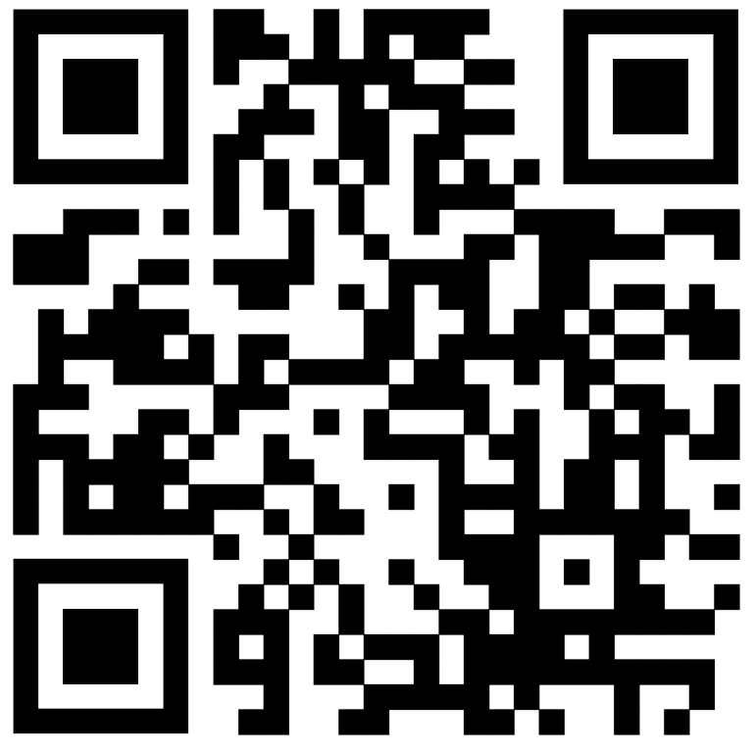

References
- Commonwealth of Australia, Department of Social Services. (2021). Australia’s Disability Strategy 2021-2031. Disability Gateway link
- Commonwealth of Australia, Department of Social Services. (2021). Australia’s Disability Strategy 2021-2031. An easy read guide. Disability Gateway link
- Australian Bureau of Statistics. (2020). Disability, ageing and carers, Australia. Data download (Queensland). A.B.S. Disability, Ageing and Carers 2020 Data link
- Queenslanders with Disability Network. (2021). Submission to the National Disability Insurance Agency Home and Living Consultation. An Ordinary Life at Home. Q.D.N. An Ordinary Life at Home 2021 link
- Griffith Inclusive Futures, Dignity Project (2020-22). Unpublished data from Dignity Project research projects. The Dignity Project link
- Queenslanders with Disability Network. (2020). Submission-Consultation RIS: proposal to include minimum accessibility standards for housing in the National Construction Code. Q.D.N. Minimum Accessibility Standards for Housing Proposal 2020 link

