Voice of Queenslanders with Disability

Employment and financial security (working and earning money)
Australia’s Disability Strategy aims to make Australia a place where people with disability can fulfil their potential as equals (be who they are, live the lives they want to live, and be treated the same as others). Queensland’s Disability Plan 2022-2027: Together, a better Queensland will help to achieve this across the state, in a way that recognises Queensland’s unique peoples, regions and diversity. This paragraph draws from references one and two.

Queensland’s Disability Plan has seven outcome areas:
- Working and earning money
- Inclusive homes and communities
- Rights, fairness and safety
- Getting support
- Learning and skills
- Health and wellbeing
- Community attitudes
This information focuses on working and earning money.

The Voice of Queenslanders with Disability will find out how these areas are changing over time. You can start having your say in early 2023 and we will produce an annual report that summarises what is happening for Queenslanders with disability.

Where do we want to be in ten years?
Good jobs, career opportunities and incomes can help people with disability live good lives. Queenslanders with disability should have:
- Preparation for employment and access to get work-related training, skills and experiences.
- Opportunities to get good jobs (and promotions) and start their own businesses.
- Enough money to live well, plan for their future, and have choice and control of their own lives.
These points draw from reference one.

What do we know about jobs and money for Queenslanders with disability now?
- Queenslanders with disability are less likely to be working or looking for work than those without disability (54% compared to 85%), less likely to be employed (49% compared to 80%), and less likely to have full-time jobs (31% compared to 55%).
- Those that are looking for work often struggle to find it. Unemployed Australians with disability find it harder to get work than those without disability (93% compared to 83%).
- However, people with disability need to access more money to achieve the same standard of living. Australian households with someone who has a profound or severe disability need $173/week more than they earn, and those with someone with mild or moderate disability need an extra $87/week.
- Two in five Australians living in poverty (38%) have disability.
These points draw from references three, four, five and six.

Intersectionality matters
- Australia’s First Peoples are more likely to have a disability and live in poverty than other Australians.
- More than two in five First Peoples households with a family member receiving the Disability Support Pension (D.S.P.) could not afford basic living expenses.
These points draw from references five and seven.

What do Queenslanders with disability say about work?

Why are people with disability less likely to be in the workforce?
Workplaces don’t always value their skills, talents, qualifications and abilities.
- “People make assumptions about my and fail to recognise my abilities. This occurs when people apply stereotypes to you.”
- “When on the pension and looking for employment, I was told to aim for factory or data entry work (despite holding two Masters’ degrees).”
- “For a high-achieving carer-driven accomplished intelligent individual, [I want] the opportunity not to “watch-paint dry!”
These points draw from reference eight.

Why are people with a disability not getting jobs when they want one?
Workplace barriers can include discrimination, a lack of reasonable adjustments and unsupportive team environments.
- “I find that you need to jump through a lot of hoops and it’s very time consuming to access supports. . . [this] excludes a lot of applicants and may be a blocker to accessing and retaining gainful employment.”
- “Most of my experiences surround others not understanding my disability or being ignorant to my needs or workplace adjustments required.”
- “I was bullied by my manager [who] excluded me from meetings. When I was in meetings, having no agenda, minutes, or written record that I could read. When I asked [for] a quick catch up to go over important points in meeting[s], she declined.”
These points draw from reference eight.

What helps people with disabilities get and keep jobs?
Disability-friendly workplaces value equality and develop creative solutions to challenges.
- “My colleagues have supported me and treated me as an equal and valued member of the team. It has been a wonderful experience and has restored my faith in my own ability as well as that of society.”
- “In my new role I have been introduced to many new technologies . . . that will help in the long term.”
- “Taking the time to look for solutions.”
These points draw from reference eight.

Where to next?
Queenslanders with disability and their family/carers (as well as disability organisations and service providers) will be able to share their experiences on the vision and seven areas of Australia’s Disability Strategy and Queensland’s State Disability Plan in early 2023.

More information and an opportunity to register your interest is available at The Voice of Queenslanders with Disability website: Link to webpage

QR Code
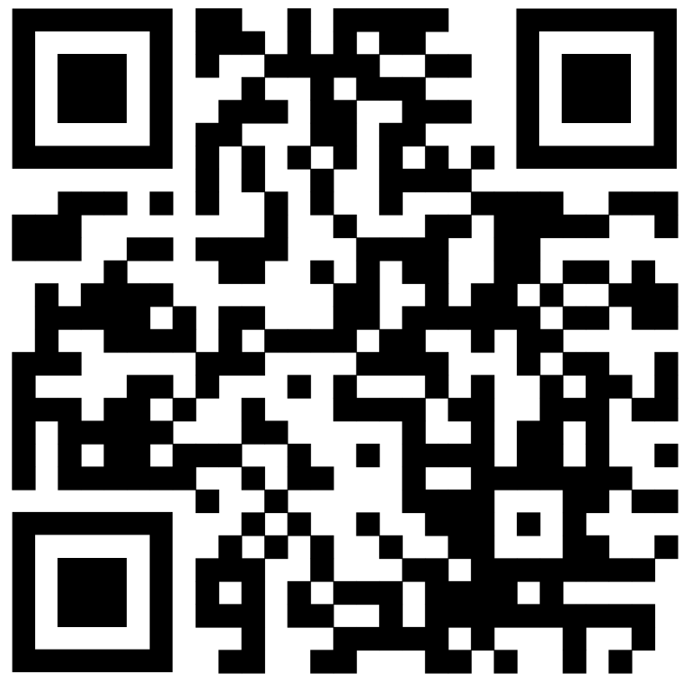

References
- Commonwealth of Australia, Department of Social Services. (2021). Australia’s Disability Strategy 2021-2031. Disability Gateway link
- Queensland Government. (2022). Queensland’s Disability Plan 2022-27. Queensland Disability Plan link
- Australian Bureau of Statistics. (2020). Disability, ageing and carers, Australia. Data download (Queensland). A.B.S. Disability, Ageing and Carers Data link
- Australian Institute of Health and Welfare. (2022). People with disability in Australia 2022. Australian Institute of Health and Welfare Report 2022 link
- Li, J., Brown, L., La, H.N., Miranti, R., & Vidyattama, Y. (2019). Inequalities in standards of living: Evidence for improved income support for people with disability. NATSEM, Institute for Governance and Policy Analysis, University of Canberra. Inequalities in standards link
- Davidson, P., Saunders, P., Bradbury, B. and Wong, M. (2018), Poverty in Australia 2018. ACOSS and UNSW. Poverty in Australia Report 2018 link
- Australian Federation of Disability Organisations. (n.d.). Poverty and disability. Fast facts. Poverty and Disability Fast Facts link
- Griffith Inclusive Futures, Dignity Project (2020-22). Unpublished data from Dignity Project research projects. The Dignity Project link

